Concentration Area: Indicate one of six concentration areas: Plant Genetic Resources; Plant breeding; Genomic analysis; Crop Science; Biosciences and Biotechnology; Plant Biotechnology

Abstract Title (Times New Roman 16, centralized)

Author¹, Author²... Maximum of 6 co-authors (Times New Roman 12, centralized)

¹ Current institution, titulation (M.Sc., D.Sc., M.Sc. Student, D.Sc. Student), corresponding email. ² Current institution, titulation. ³ It must be written in Times New Roman font size 10, centralized.

Abstract: The abstract should be written with short and direct sentences. The text must be written in Times New Roman font size 12, justified. The abstract should not contain more than 300 words. You should inform in the first sentence the purpose of the work. Therefore, the methodology should be presented highlighting mainly the experimental design adopted and the statistical analysis performed, as appropriate. Next, the main results obtained with the research should be indicated. All the abstract should be written in a single paragraph. After the abstract should be indicated three to five keywords, which are words that are not present in the title. For abstracts written in English, the topic “Abstract” (written in English) should precede the topic “Resumo” (written in Portuguese).

Keywords: keyword; keyword; keyword; keyword.

Resumo:

Palavras-chave:

INTRODUCTION

Abstracts may be written in Portuguese or English, according to authors' choice. All text component of the research development should be written in Times New Roman font size 12, justified, in line spacing (1.5 pts), with no space between paragraphs. As for page layout, the text should be written in A4 size, portrait orientation, with custom margins: 2 cm for all margins. The abstract (including the references) must not exceed six pages.
The title of the abstract should be written in Times New Roman, size 16, bold, centered. The title should contain a maximum of 15 words. Right after the title, it should be written the names of the authors (Ex: Full Name da Silva) followed by the description number of their respective affiliation.
The abstract development should contain Introduction, Materials and Methods, Results and Discussion, Conclusion and References, respecting the order. With each new development topic, there should be two simple white spaces between the end of the text in the previous section and the title of the next topic and a simple white space between the title and text in the section. The title of the topics should be written in capital letters, bold, in Times New Roman font size 12.
The Introduction topic is the justification of the work. Here it should be clearly presented the facts that motivated the development of research and therefore justify the importance of the research.
It is recommended that the introduction be no less than four and no more than eight paragraphs. The last paragraph of the introduction should state the purpose of the research, which should be fully answered in the concluding topic.

MATERIAL AND METHODS

The deadline for submission of expanded abstracts to the Organization of the III Workshop in Genetics and Plant Breeding is October 20, 2019. Abstracts should be sent via e-mail (Jobswgpb@gmail.com) in doc or docx file format. The same email may be used to answer any questions that may arise regarding the formatting and submission of papers. Abstract submission does not mean approval of the same. Once the registration payment has been identified, the abstract submitted by the participant will be corrected by expert reviewers in the specific areas of each abstract. Final acceptance will be announced by November 04, 2019.
The methodology should clearly and concisely specify the materials used, as well as the methodologies for evaluation and statistical analysis. It is also worth noting that, when appropriate, the experimental design adopted and the statistical analysis methodology should be clearly described.
It is recommended the use of tables to describe the genetic materials, when dealing with a large number of materials (treatments). Sketches and images showing the steps of conducting the experiments, when possible, are still encouraged.

RESULTS AND DISCUSSION

The results constitute the information obtained from the data generated throughout the research. It is recommended to use tables and graphs to present the results, always remembering that graphs tend to present larger volume of information per unit of space. Thus, the use of graphs can avoid the need for extensive result tables, especially in cases where there is a high number of treatments.
It is important to highlight that in this topic the results should not only be presented but also discussed.
Tables should not contain vertical lines, and as few horizontal lines as possible (Table 1). Tables and figures should be presented right after their first correspondence in the text.

Table 1. Description of the 10 bean genotypes evaluated in three different environments in the state of Rio de Janeiro.
Identification | Genotype description* | Crop location
01 | Feijão Carioca | Rio de Janeiro – RJ
02 | Feijão Amarelo | Fortaleza - CE
03 | Feijão Preto de Minas | Viçosa – MG
04 | Feijão do Frade | Seropédica – RJ
05 | Feijão Branco | Alegre – ES
06 | Feijão Carioca | Campos dos Goytacazes – RJ
07 | Feijão Vermelho | Alta Floresta – MT
08 | Feijão Rajado | Rondonópolis – MT
09 | Feijão Anjinho | Salvador – BA
10 | Feijão Amarelo | Vitória – ES
* Subtitles should be written in Times New Roman font size 10.

Before and After presenting a table or figure, there should be a simple blank space separating the figure or table from the following text. Figures should contain their titles at the bottom (Figure 1).

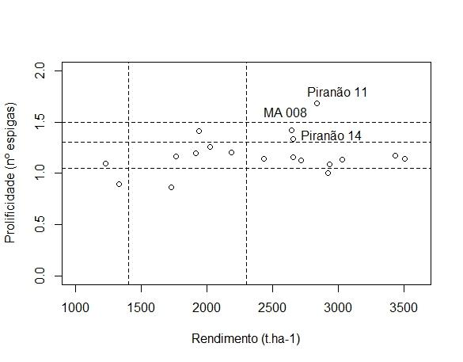
Figure 1. Dispersion of 21 common maize populations as a function of ear prolificacy average and grain yield cultivated under water deficit in Colatina - ES.

It is worth noting that the figures should have good resolution, and the image quality should not be a factor that hinders the understanding of the information presented by it.
Citations made throughout the discussion of results should follow the standards given in this document. When citations are made in plain text, the author's last name should be presented with only the initial capital letter and the year of publication indicated in parentheses. When the work is written by three or more authors, only the last name of the first author may be cited, followed by the abbreviation "et al.". Examples: Silva (2019), Silva and Souza (2019), or Silva et al. (2019).
When citations are made at the end of sentences, references to authors should be written in parentheses, in capital letters, followed by the year of publication. Examples: (SILVA, 2019), (SILVA and SOUZA, 2019) or (SILVA et al., 2019).
The last paragraph of this topic should indicate what is expected from the results obtained in this research as contributions to plant breeding and biotechnology, and related areas.

CONCLUSION

The conclusion should present only and exclusively the results expected with the objective of the research. There should be no repeated statements already made in the results and discussion topic. Conclusions should not be numbered.

REFERENCES

All references cited in the text should be described in this section. Whenever possible, indicate the doi or access link to the cited paper. Between each reference there should be a single blank space.

The standards for the elaboration of references will follow the models presented below:

Jornal papers: Duncan KE and Howard RJ (2010) Biology of Maize Kernel Infection by Fusarium verticillioides. Molecular Plant-Microbe Interactions 23(1): 6-16.
Books: Hallauer AR, Carena MJ and Miranda Filho JB (2010) Quantitative genetics in maize breeding. Springer, New York, 664p.
Book chapters: Morais PPP and Borem A (2017) GM cultivars. In Silva FL, Borem A, Sediyama T and Ludke WH (eds) Soybean breeding. Springer, New York, p. 174-189.
Papers presented in congresses: Almeida RN, Marques Júnior E, Campanharo IF, Assis AA, Ferrari JL, Garcia RF (2010) Variabilidade espacial da infestação de moscas-das-frutas num pomar de citros. XIV Encontro Latino Americano de Iniciação Científica. São José dos Campos, São Paulo, p. 1-4.

